Department of Customer Service 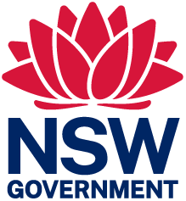

14 September 2023
Re: Technology Assisted Voting in NSW - Interim Report
Dear Technology Assisted Voting (TAV) Review Team

Thank you for the opportunity to provide further comment. Accessibility NSW is pleased to note its advice was considered, as was that of groups representing people with disability like Vision Australia, Deaf Australia and the Council for Intellectual Disability.

Accessibility NSW is eager to ensure all NSW citizens can vote without facing accessibility barriers. As noted in Appendix 2, accessibility and usability are essential principles for a democratic voting process.

As noted in the report, Accessibility NSW is in favour of a range of options for voting that individuals can self-select based on their own needs. All options discussed in the paper can present both accessibility benefits and accessibility barriers, depending on the needs of the voter. This is demonstrated in the advice given by advocacy groups (for example, the differing views on kiosk voting expressed by Vision Australia and Blind Australia). For this reason, the most effective accessibility measure is to offer options.

As per our previous advice, any digital voting option should be tested for accessibility against the international standards (the procurement standard AS EN 301 549 and the latest version of the Web Content Accessibility Guidelines (WCAG) at level AA), and its accessibility should be confirmed by useability testing by people with lived experience of disability and people who use assistive technology. Testing should occur during procurement/development and after deployment. This will ensure the digital voting solution itself is accessible for voters.

Accessibility NSW would be happy to provide information if required.

Sincerely,

Anjelica Paul
Principal Policy Officer, Accessibility NSW

